Name _______________________________ Date _________________
Unit 4: Division
Think about the skills below. Assess your knowledge of each concept. Show an example of each concept.

Skills  I can… | I can do this on my own and explain how it works.  (Secure) | I can do this on my own.  (Developing) | I can do this if I have help or look at an example.  (Beginning) | Explanation/ Examples/ Notes
find whole number quotients of whole numbers with up to 4-digit dividends and 2-digit divisors. |  |  |  | - Study Link 4.4  - Study Link 4.5  - Study Link 4.6
make magnitude estimates for division. |  |  |  | - Lesson 4.5 Page 109  - Study Link 4.5
divide decimals by whole numbers. |  |  |  | - Lesson 4.5 Page 109 #6  - Study Link 4.5 #6  - Lesson 4.6 Page 112  - Study Link 4.6
use a calculator to write exponents in standard form |  |  |  | 4³ = 64  2⁵ = ______  3⁴ = ______
use multiplication to prove that the answers to the following division problems are correct. |  |  |  | 315 / 7 = 45  45 X 7 = 315  Knowing the Fact Family
use divisibility tests to determine if one number is divisible by another number. |  |  |  | - Divisibility Chart
solve for a missing number in an equation involving a single operation. |  |  |  | - Study Link 4.7
choose the correct operation to solve a problem. |  |  |  | - Math Binder Problem Solving  Read a math story and decide if they should use addition, subtraction, multiplication, or division.
Skills  I can… | I can do this on my own and explain how it works.  (Secure) | I can do this on my own.  (Developing) | I can do this if I have help or look at an example.  (Beginning) | Explanation/ Examples/ Notes
apply a formula to find the volume of rectangular prisms. |  |  |  | - V = Length X Width X Height  = 17 in. X 11in X 9 in  = 1,683 in  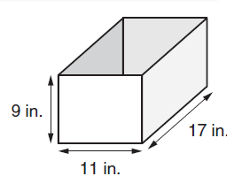
Convert volume measurements using a table |  |  |  | - Study Link 11.6  